**IQR Exercise**

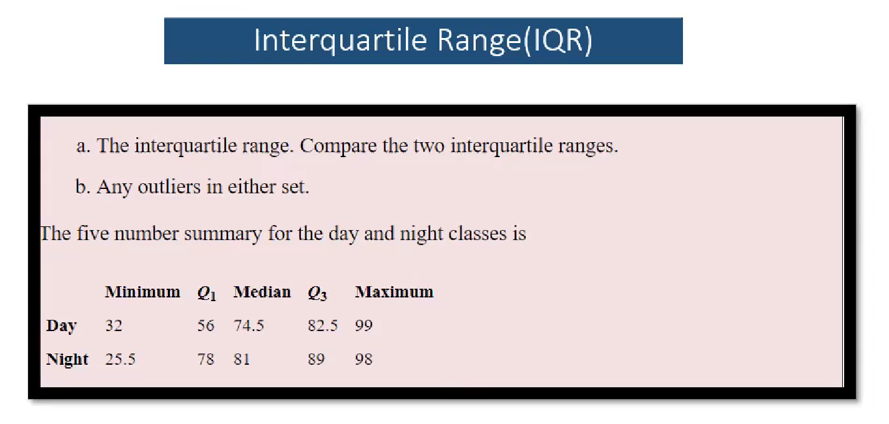

**Day:**

**IQR = Q3-Q1 = 82.5 - 56 = 26.5**

**IQR = 1.5*26.5 = 39.75**

**Lesser Range= Q1 - 39.75 = 56 - 39.75 = 16.25**

**Greater Range = Q3 + 39.75 = 82.5 + 39.75 = 122.25**

No Outlier

**Night:**

**IQR = Q3-Q1 = 89 - 78 = 9**

**IQR = 1.5*9 = 13.5**

**Lesser Range = Q1 - 13.5 = 78 - 13.5 = 64.5**

**Greater Range = Q3 + 13.5 = 89 + 13.5 = 102.5**

Found Outlier because Minimum values is(25.5) is lesser Range (64.5)